**1.Modelo RF5_Indeg Apoio Spe tubos X All var**.

***Instrucciones modelo***: **test size = 0.23 ; rd_state = 3.**

***Variables indep select to fit***:

variables = ['id', 'Indeg_IntimAmigos_', 'Indeg_RedeRisk_Cen', '1_VarExp_Moranca', '2_VarExp_Atri_Tabanca', '5_VarExp_Atri_Idade',

'Area_bolanha', 'OutDeg_RedeRisk_Cen','OutDeg_RedeConfianc']

***Model performance (scores):***

Mean Squared Error: 0.4333

R^2 Score: 0.4437 (In Excel: R2 = 0.4565 ; y = 0.4565 X + 0.9515)

**Model tot:**

Mean Squared Error (MSE): 0.2946

Root Mean Squared Error (RMSE): 0.5427

Mean Absolute Error (MAE):0.2636

R^2 Score: 0.7122

Pearson Correlation: 0.8571

***Interactions***:

| **Interacción** | **Importancia** | **Dirección** |
| --- | --- | --- |
| 0 | (1_VarExp_Moranca, Area_bolanha) | 0.209611 | 0.002230 |
| 1 | (2_VarExp_Atri_Tabanca, Area_bolanha) | 0.207512 | 0.161827 |
| 2 | (Degree_RedeTotFamil, Area_bolanha) | 0.197745 | 0.025353 |
| 3 | (Area_bolanha, OutDeg_RedeConfianc) | 0.196759 | 0.009248 |
| 4 | (1_VarExp_Moranca, 2_VarExp_Atri_Tabanca) | 0.189554 | 0.000929 |
| 5 | (Indeg_IntimAmigos_, Area_bolanha) | 0.187689 | 0.005487 |
| 6 | (5_VarExp_Atri_Idade, Area_bolanha) | 0.181713 | 0.004021 |
| 7 | (2_VarExp_Atri_Tabanca, OutDeg_RedeConfianc) | 0.176002 | 0.213737 |
| 8 | (Indeg_IntimAmigos_, 5_VarExp_Atri_Idade) | 0.168981 | 0.007895 |
| 9 | (Degree_RedeTotFamil, 2_VarExp_Atri_Tabanca) | 0.167629 | 0.023098 |

***Key results****:*

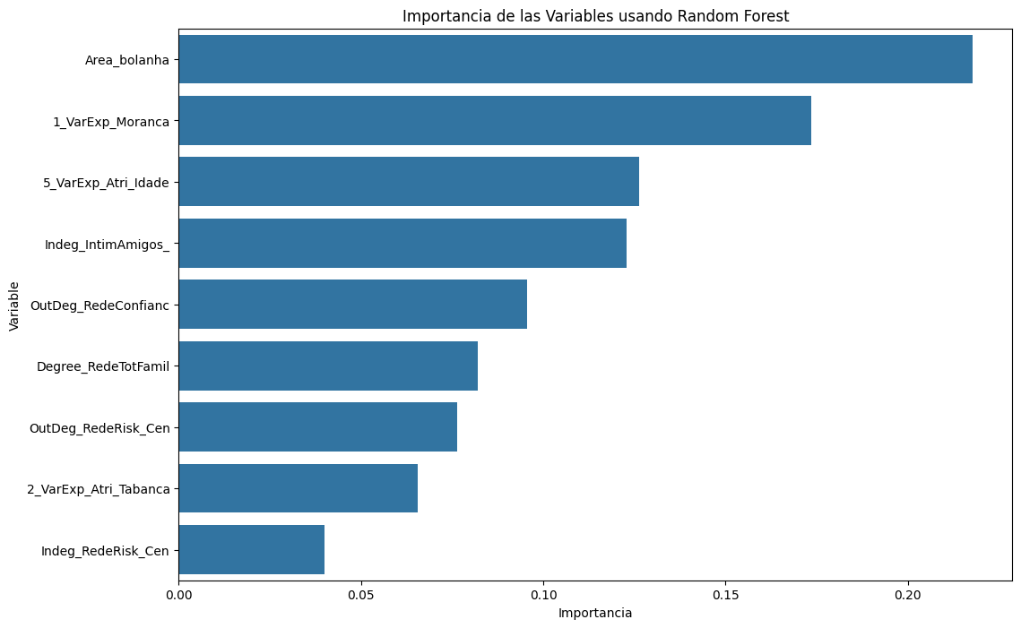 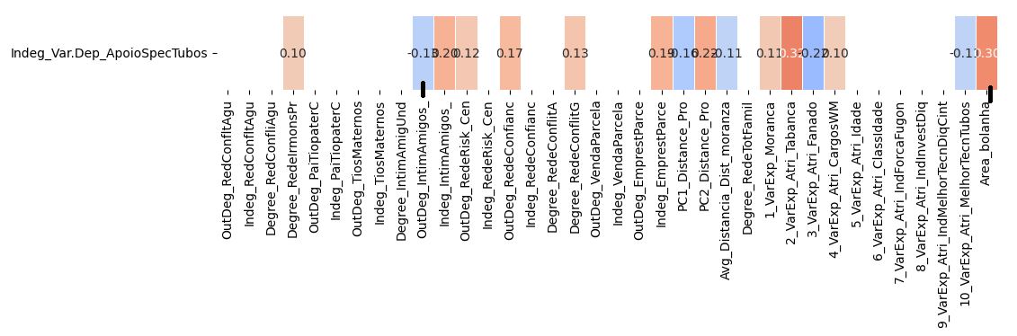

**1.Modelo RF5_Outdeg Apoio Spe tubos X All var**.

***Instrucciones modelo***: **test size = 0.23 ; rd_state = 3**

***Variables indep select to fit***:

variables = ['id', 'Degree_IntimAmigUnd', 'Indeg_RedeConfianc', 'Degree_RedeTotFamil', '7_VarExp_Atri_IndForcaFugon', '9_VarExp_Atri_IndMelhorTecnDiqCint', '10_VarExp_Atri_MelhorTecnTubos']

***Model performance (scores):***

Mean Squared Error: 0.4667

R^2 Score: 0.9237 (on excel: **R2= 0.9406 ; Y = 0.8171 X + 2.069** )

**Model tot:**

Mean Squared Error (MSE): 5.33

Root Mean Squared Error (RMSE): 2.3094

Mean Absolute Error (MAE): 0.4651

R^2 Score: 0.9337

Pearson Correlation: 0.9937

***Interactions***:

| **Interacción** | **Importancia** | **Dirección** |
| --- | --- | --- |
| 0 | (7_VarExp_Atri_IndForcaFugon, 10_VarExp_Atri_M... | 11.234918 | 0.919345 |
| 1 | (Indeg_RedeConfianc, 10_VarExp_Atri_MelhorTecn... | 11.199238 | 1.006930 |
| 2 | (Degree_IntimAmigUnd, 10_VarExp_Atri_MelhorTec... | 11.167017 | 0.172229 |
| 3 | (Degree_RedeTotFamil, 10_VarExp_Atri_MelhorTec... | 10.979623 | 0.109391 |
| 4 | (9_VarExp_Atri_IndMelhorTecnDiqCint, 10_VarExp... | 10.915314 | 0.121743 |
| 5 | (Indeg_RedeConfianc, 7_VarExp_Atri_IndForcaFugon) | 2.998382 | 1.002968 |
| 6 | (Indeg_RedeConfianc, 9_VarExp_Atri_IndMelhorTe... | 2.302823 | 1.001513 |
| 7 | (Degree_IntimAmigUnd, Indeg_RedeConfianc) | 2.292305 | 0.135826 |
| 8 | (Indeg_RedeConfianc, Degree_RedeTotFamil) | 2.239744 | 0.993353 |
| 9 | (Degree_IntimAmigUnd, 7_VarExp_Atri_IndForcaFu... | 1.550193 | 0.135049 |

***Key results****:*



